Customer Journey Map

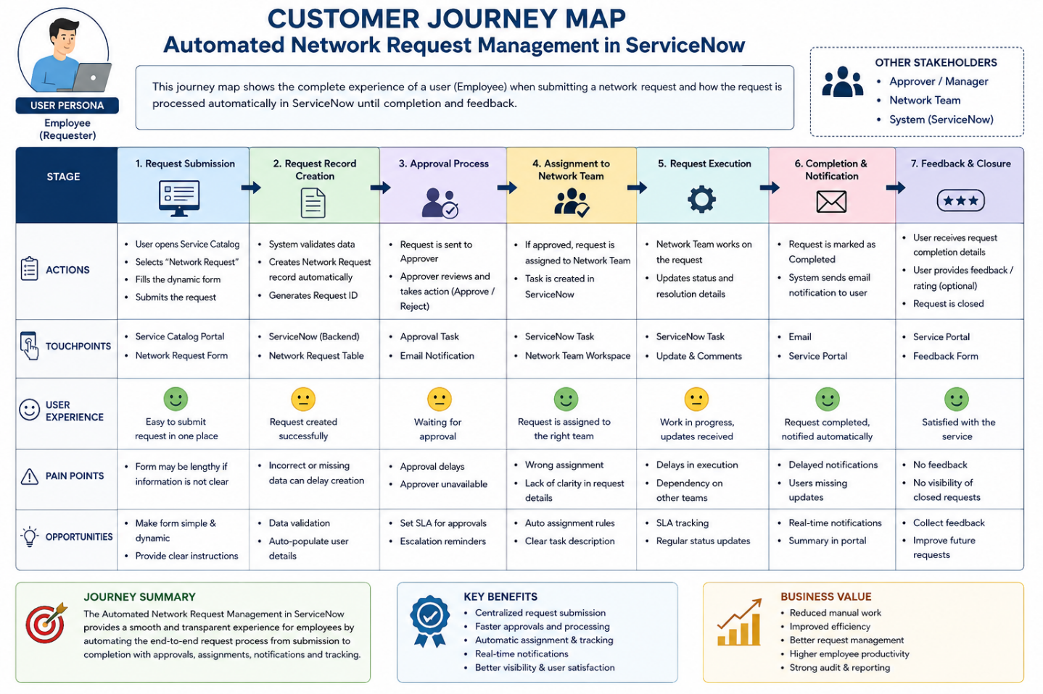
Journey Stage | Customer Actions | Touchpoints | Feelings | Pain Points
1. Need Identification | Employee identifies the need for a new network connection or relocation. | Team/IT discussion | Hopeful | Unclear  process
2. Request Submission | Employee logs in, fills the request form and submits it. | Service Portal | Confident | Too many fields, manual entry
3. Request Review | IT team checks request details and requirements. | IT Dashboard | Neutral | Delay in review
4. Approval | Request is sent to the concerned approver for approval or rejection. | Approval Task / Email | Anxious | Waiting for approval
5. Fulfillment | IT team implements the approved network request. | IT/Network System | Relieved | Implementation delays
6. Notification & Tracking | Employee receives updates and tracks request status. | Email / Service Portal | Satisfied | Lack of real-time updates
7. Completion & Feedback | Employee confirms completion and provides feedback. | Feedback Form / Portal | Happy | Limited feedback options

Key Insights
Employees need an easy way to submit and track network requests. Manual approvals and communication can cause delays and confusion. Automation provides faster processing, real-time status updates, and automatic notifications. A centralized system helps the IT team manage requests efficiently and improves transparency, reliability, and user satisfaction.

